**Full Life Behavior & Training**

**Management for Canine Behavior Problems**

True behavior modification takes time and management is often needed for the safety of those living with a dog who is struggling with unwanted behaviors. Management usually involves separating the dog from people or other animals at specific times, complete separation with a slow re-integration, and/or long-term management tools.

Examples include:

* leaving a dog who is nervous of strangers in his own room when visitors are in the home.
* separating dogs who resource guard when feeding and giving chews.
* using muzzles for dogs with a bite history.

Tools I recommend:

**Stress Relief**

Adaptil products: https://www.adaptil.com/us

Music: https://icalmpet.com/

Chews: stuffed Kongs, marrow bones, and hooves, Nutri Chomps, Nylabone Healthy Edibles, and bully sticks

Supplements & Calming Aids: Purina Pro Plan Calming Care, Zylkene, Composure (best for small pets)

*Always speak with your veterinarian before using any over the counter supplements or calming products.* These can have unwanted reactions with prescription medications and your vet may need to help you with correct dosing. Read and follow instructions thoroughly before and during use.

**Confinement**

Pet Gates with swing doors:

Buy the tallest gate available, especially for larger dogs. I recommend using the screw feature to attach the gate firmly in doorways. Adjustments can be made if the dog paws the gate open, and baby gates can be stacked above it if your dog jumps the gate.

Stacked Baby/Pet Gates

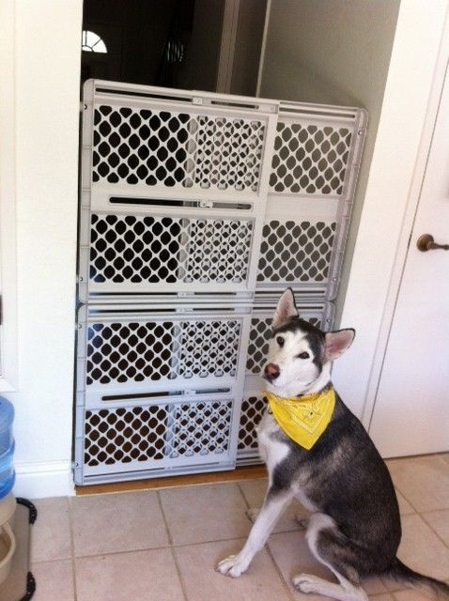

Look for high quality gates. Gates advertised for pets are often sturdier than those advertised for children. The gates can be stacked in doorways to prevent jumping.

**Exercise Pens**

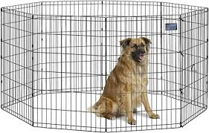

I recommend metal exercise pens versus plastic, and never fabric. These gates can be shaped to fit your space and folded when not in use. I recommend buying the tallest available, usually 48 inches. Covers can be rigged for dogs who jump.

More than one pen can be attached together for additional space, and they can be strengthened with zip ties and carabiners. Heavy objects such as cinder blocks can be put on the outside of the pen for dogs who move them around.

Can be an excellent option for dogs who do not tolerate being crated but need to be confined when unsupervised.

**Muzzles**

Muzzles should be used for dogs with a bite history or who display a high risk of biting. Muzzles are not a quick fix, behavior modification will still be needed, most dogs need to be acclimated to a muzzle before use, and these tools should be used under supervision. These tools are not intended to prevent chewing or barking.

Free information on types of muzzles and acclimation:

muzzleupproject.com

YouTube: Teaching a Dog to Wear a Muzzle (Muzzle Training) by Chirag Patel

Basket Muzzles

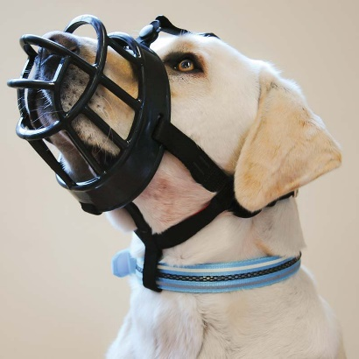

For long term use and use during training. The dog should be able to open their mouth, take treats, pant, and drink water. Dogs need a daily break from their muzzle, especially for time to chew. Gauze can be wrapped around parts of the muzzle that touch the dog if it rubs.

I usually recommend the Baskerville Ultra muzzle, but many other brands and styles are available depending on the level of management needed.

Soft Muzzles

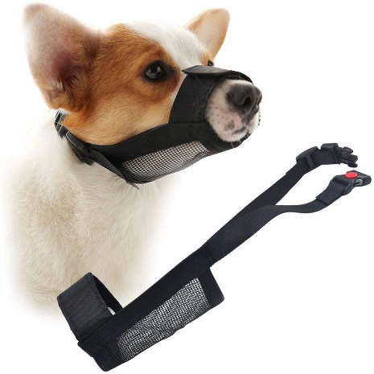

For short term use such as at the vet and the groomer. Many styles and brands are available. When fitted properly the dog’s mouth should be held entirely shut. Dogs cannot pant and heat regulate when wearing a properly fitted soft muzzle, so it should not be used for long periods of time. Lickable treats such as baby food and cream cheese can be given when a dog is wearing this style of muzzle.

Brachiocephalic Muzzles

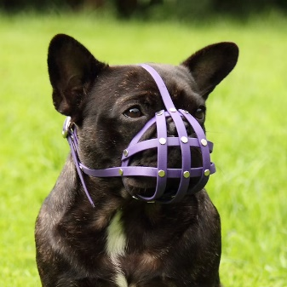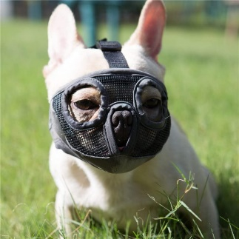

For “smooshy” nosed breeds such as bulldogs, pugs, and shih tzus. It’s especially important that these breeds be able to heat regulate, and you will likely need a professional to help you choose the right brand/style for your dog.